**Master - Slave configuration**

------------------------------------

Same version of java should exist.

Master and slave should have password less SSH

Step 1: Create slave machine, connect to slave

1) Update the apt repository

sudo apt-get update

2) Install java

sudo apt install openjdk-8-jdk -y

3) Check the Java Version

java -version

We need to establish password less connection between Dev server and Slave machine

Connect to slave

7) Check you user

$ whoami (ubuntu)

8) set password for ubuntu user

syntax: sudo passwd <user_name>

Ex: sudo passwd ubuntu

enter password

$ cd /etc/ssh

$ ls (we get list of files) Look for sshd_config

To edit sshd_config

$ sudo vim sshd_config

Go to insert mode

change password authentication to yes

13) Save and quit :wq

14) Restart the service

$ sudo service ssh restart

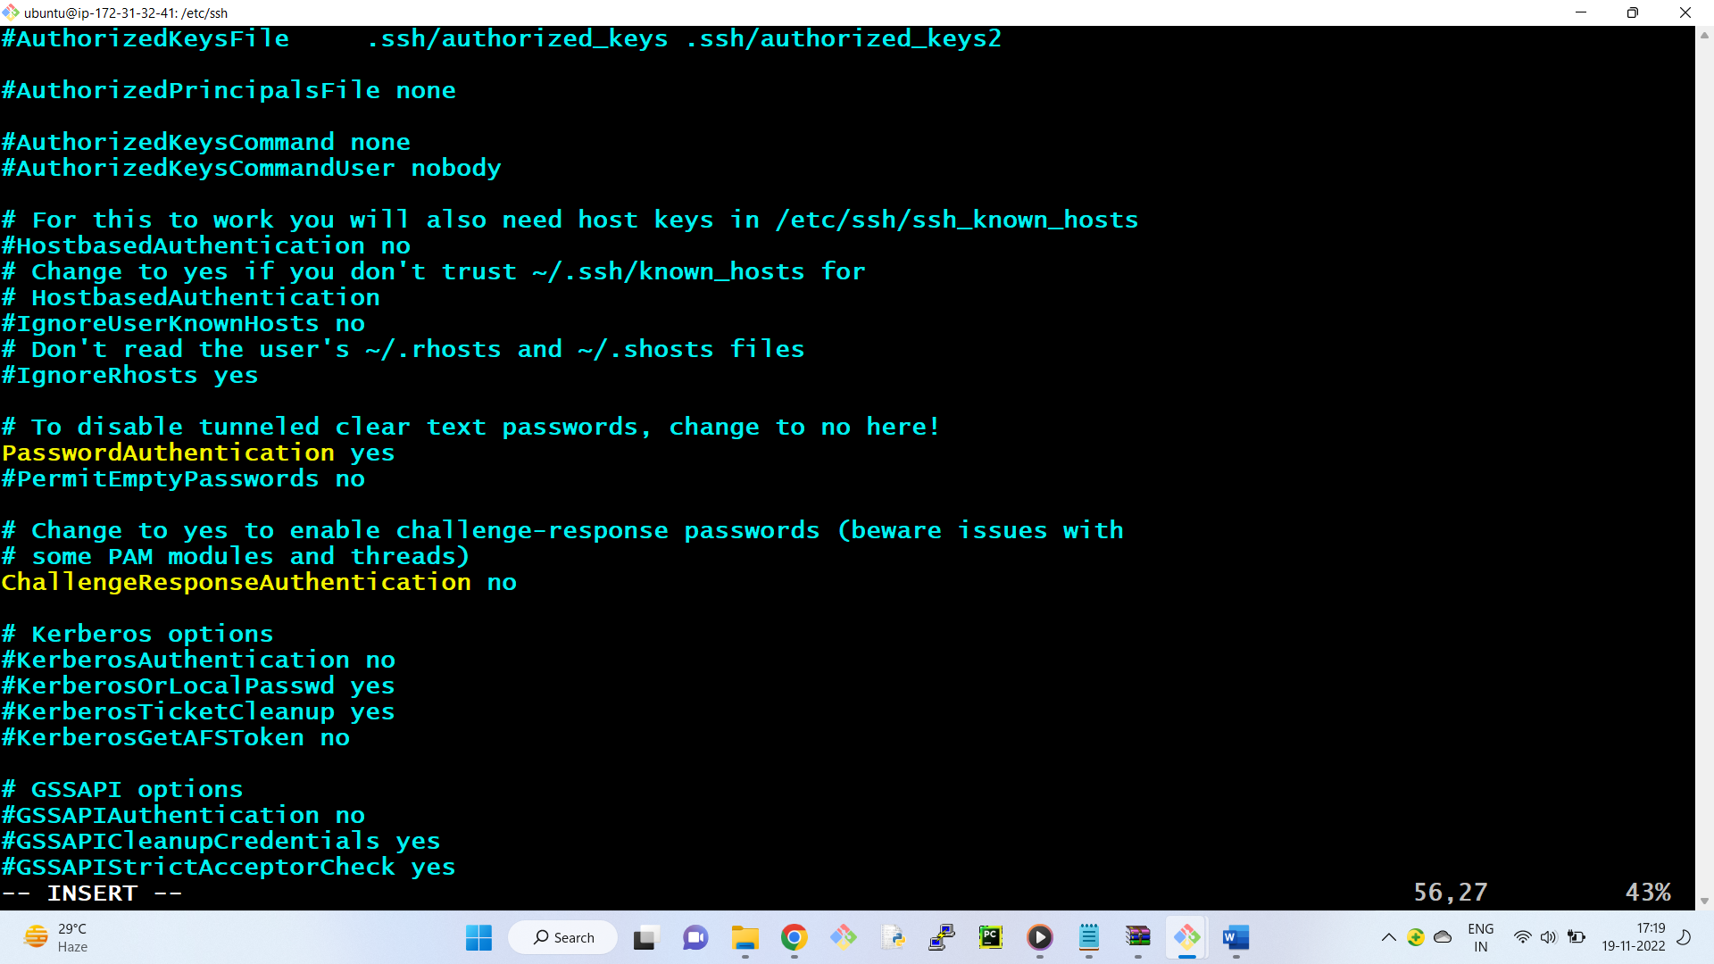

Let’s test the connection

-------------------------------

15) Connect to the development server (Master)

16) connect to slave server through dev server

ssh ubuntu@private_ip_slave_machine

$ ssh ubuntu@172.31.1.107

exit (to come back to master)

+++++++++++++++++++++++++++++++++++++++

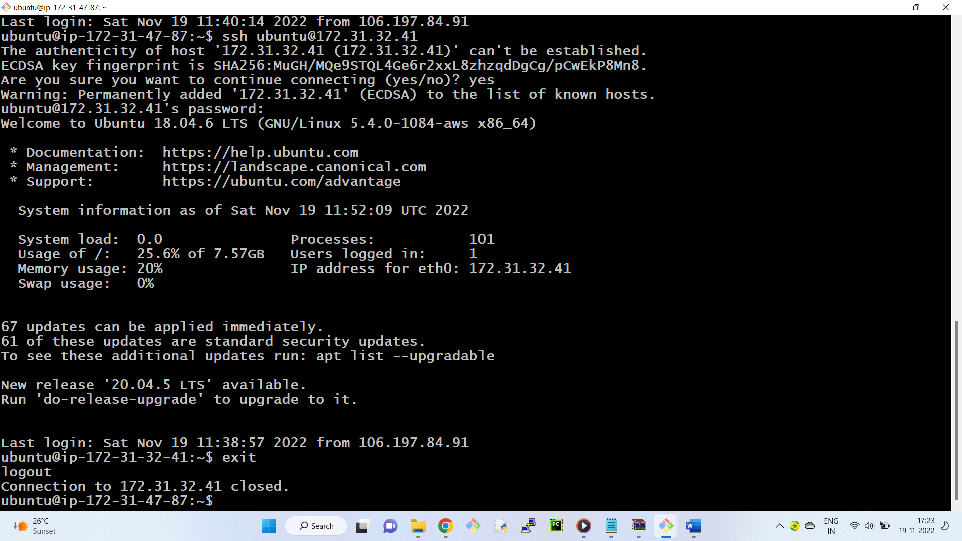

17) To connect to slave without password

$ ssh-keygen (In master)

18) copy the keys to slave server

ssh-copy-id ubuntu@private_ip_slave_server

ssh-copy-id ubuntu@172.31.1.107

19) now we are able to connect to the slave user without password

$ ssh [ubuntu@172.31.1.107](mailto:ubuntu@172.31.1.107)

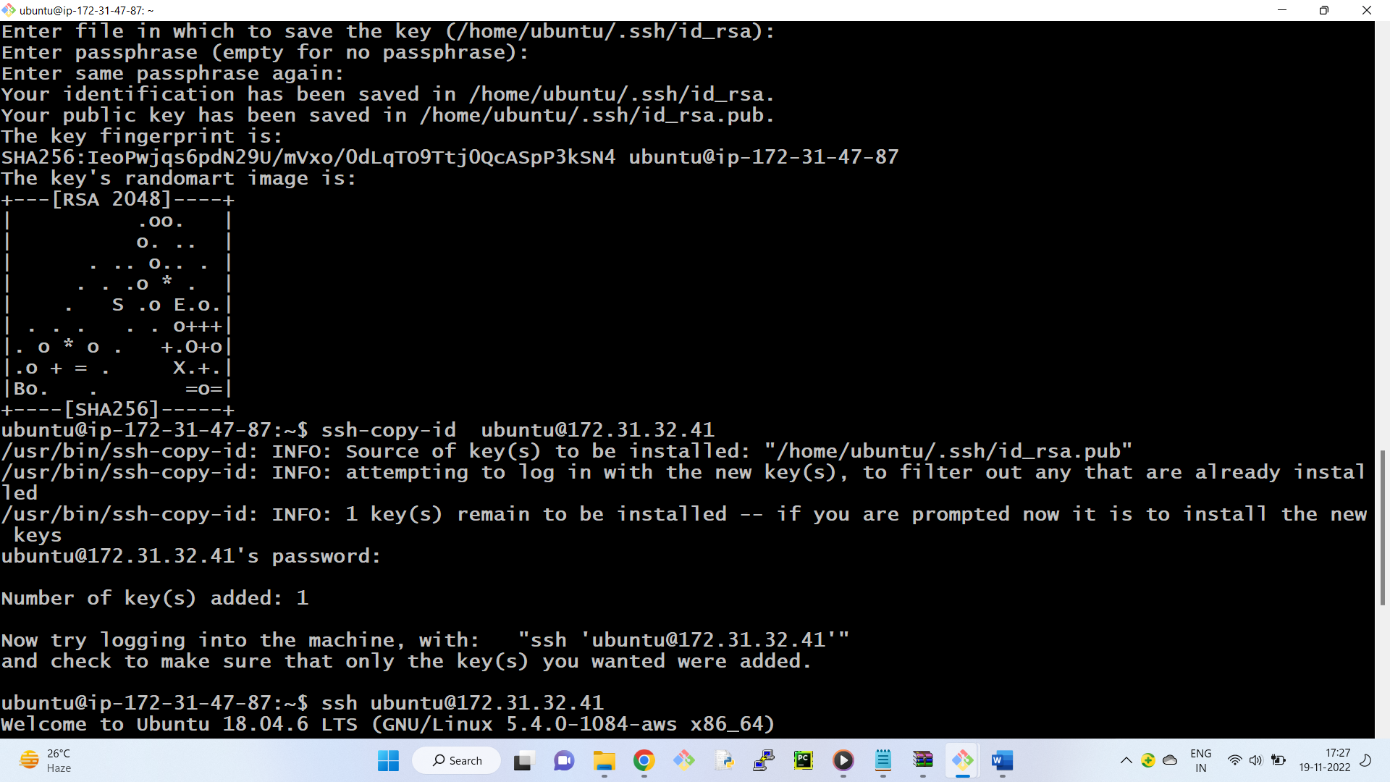

Download slave.jar in slave machine

sudo wget <http://devserverpvtip:8080/jnlpJars/slave.jar>

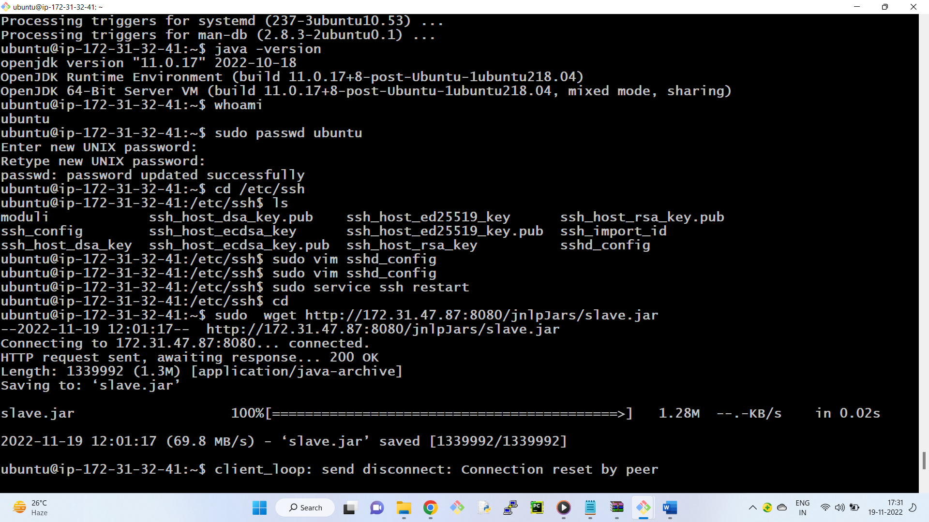

Check the file is download or not

$ ls

check the file permissions

$ ls -l

we want rwxr--r--

3) Give execute permissions of this file

sudo chmod u+x slave.jar

4) Create an empty folder which will work like workspace for jenkins to use on the slave machine

$ mkdir workspace

$ cd workspace

$ pwd ( note the path of the workspace )-- /home/ubuntu/workspace

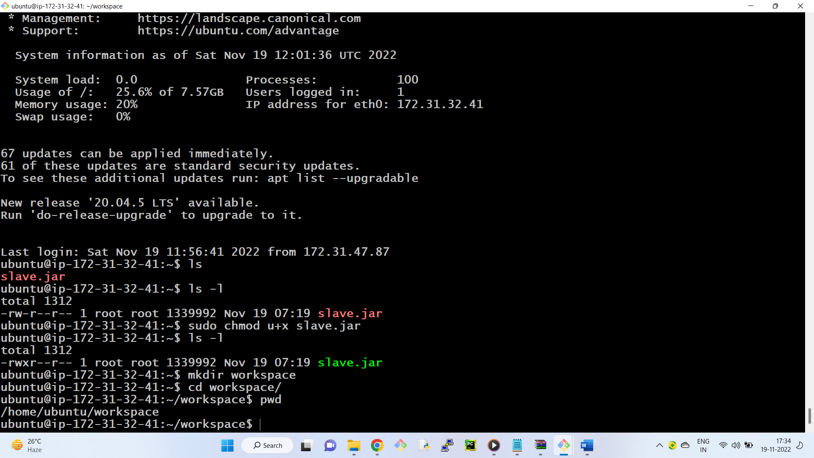

**Creating node in Jenkins**

---------------------------

1. Open the dashboard of jenkins
2. manage jenkins --- manage nodes

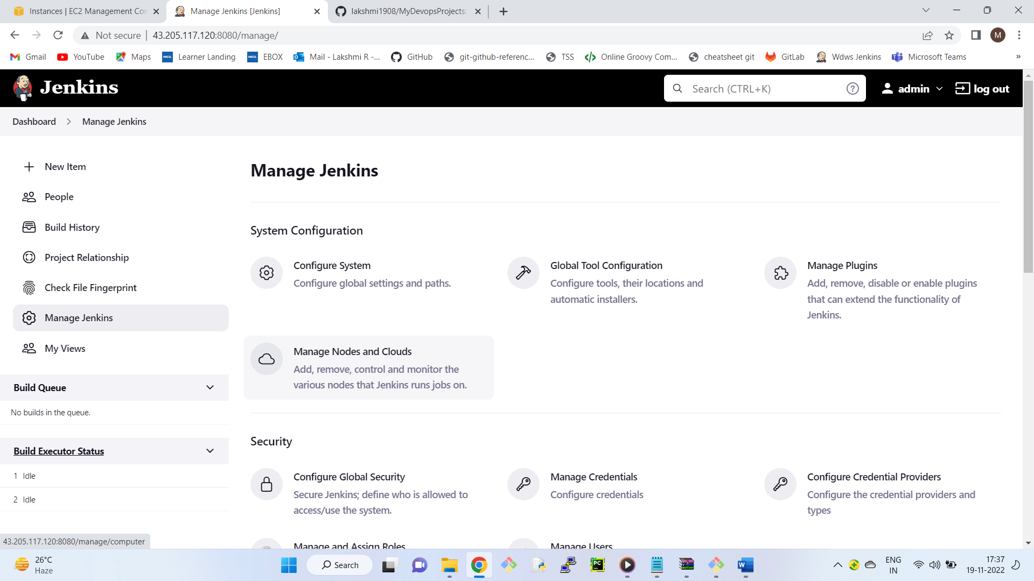

3) Click on new node ---- node name - Myslave

- select permanent agent

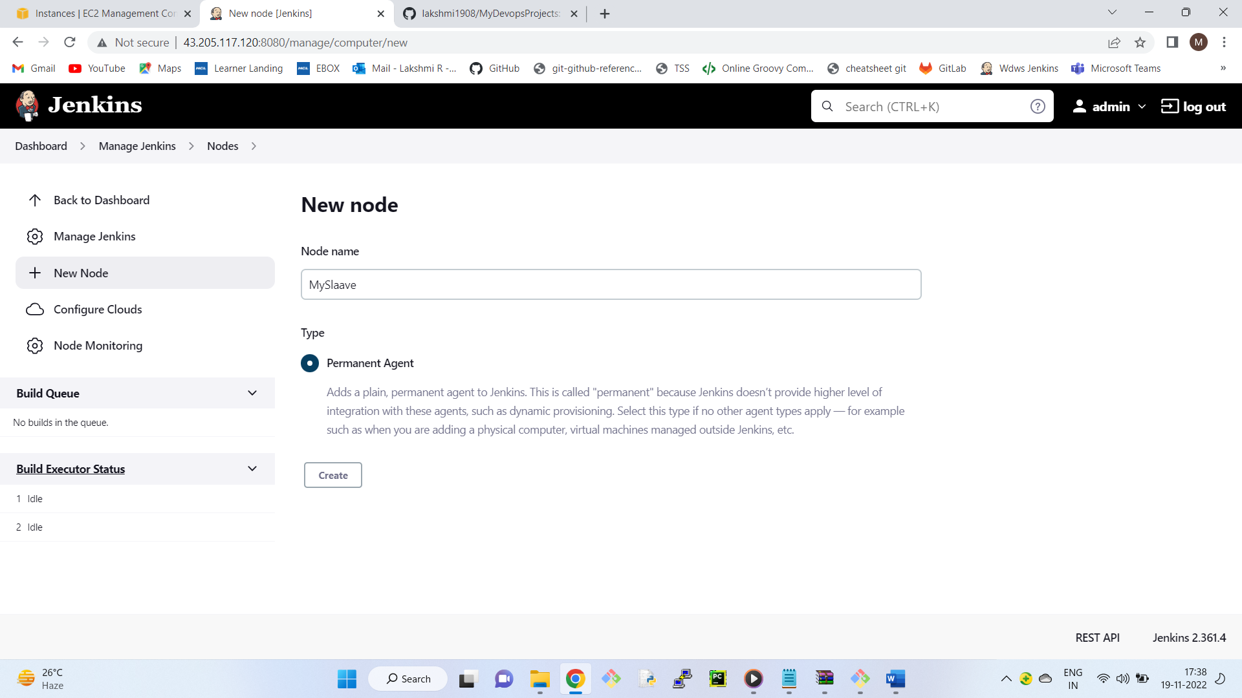

Remote root directory -/home/ubuntu/workspace

Label - Slave_lab

4) Go to Launch method

Select Launch agent via execution of command on the controller

5) In Launch command

ssh ubuntu@private_ip_of_slave java -jar slave.jar

ssh ubuntu@172.31.1.107 java -jar slave.jar

6) Click on save

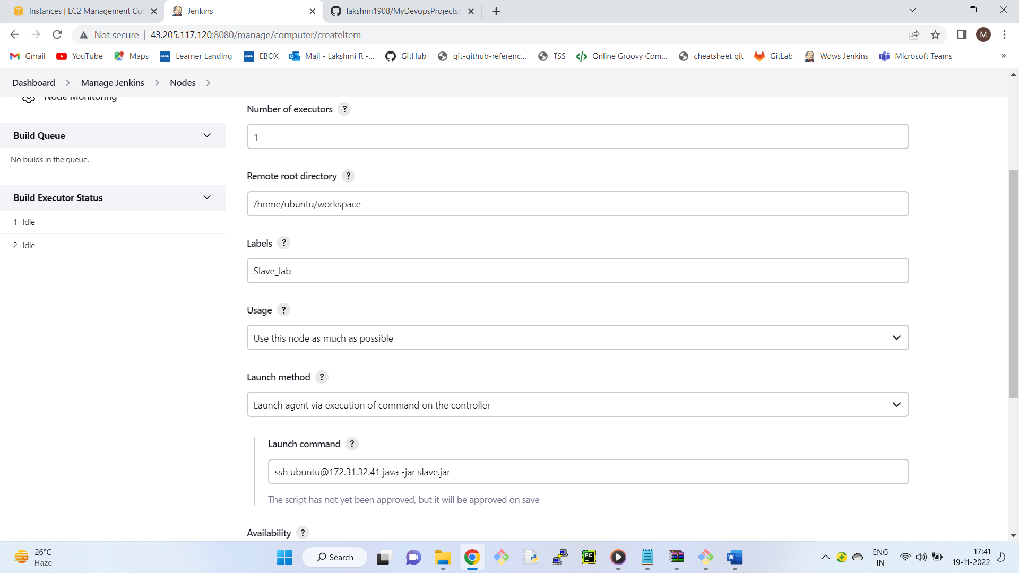

Configure job to run on slave

------------------------------

7) Select Testing Job

8) Go to Configure --> General Tab

9) Check Restrict where this project can be run

10) Enter Label Expression (Slave_lab)

Apply ---> Save

Run the job, In console output, we can see the job is executed in slave machine

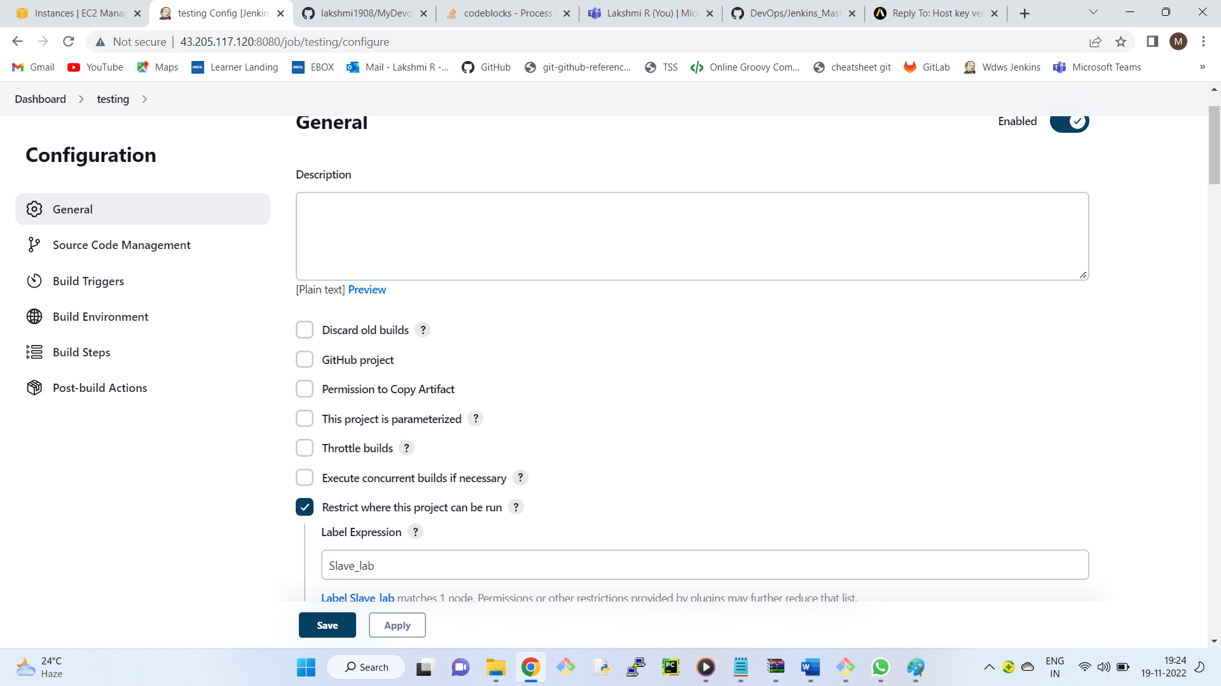

If MySlave is not ready follow the below instructions.

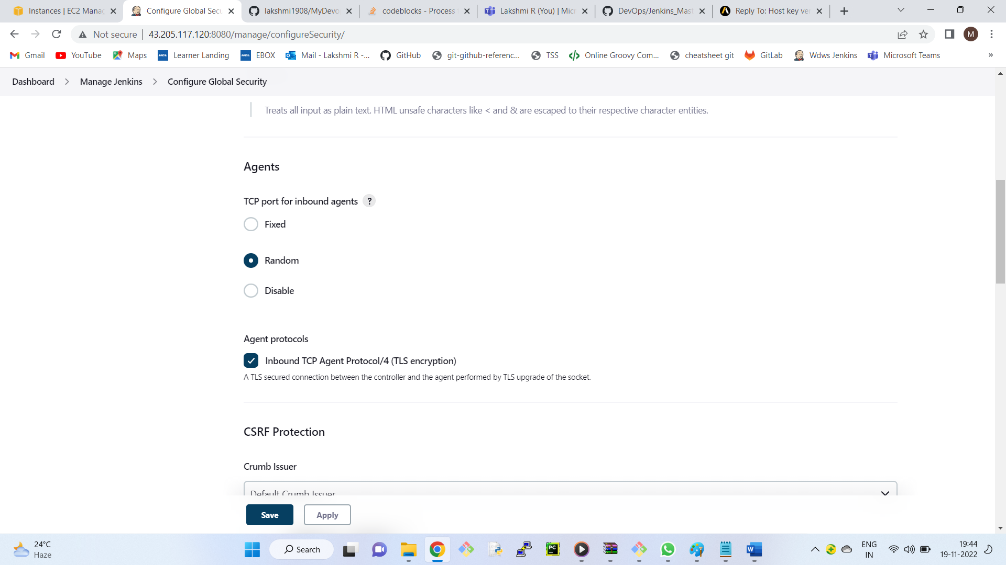

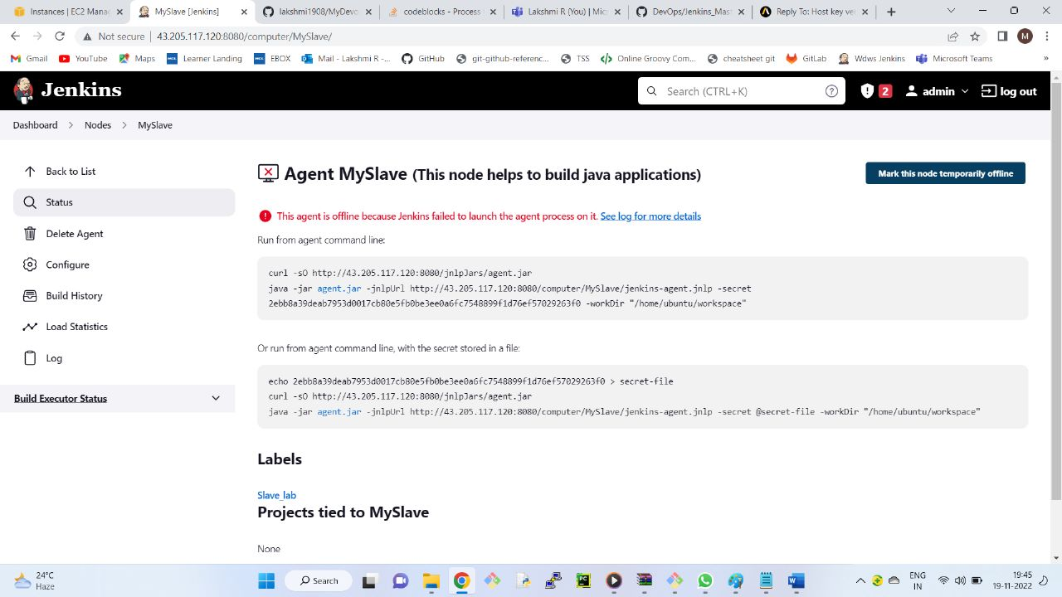

Run any one of the above command in the slave node.

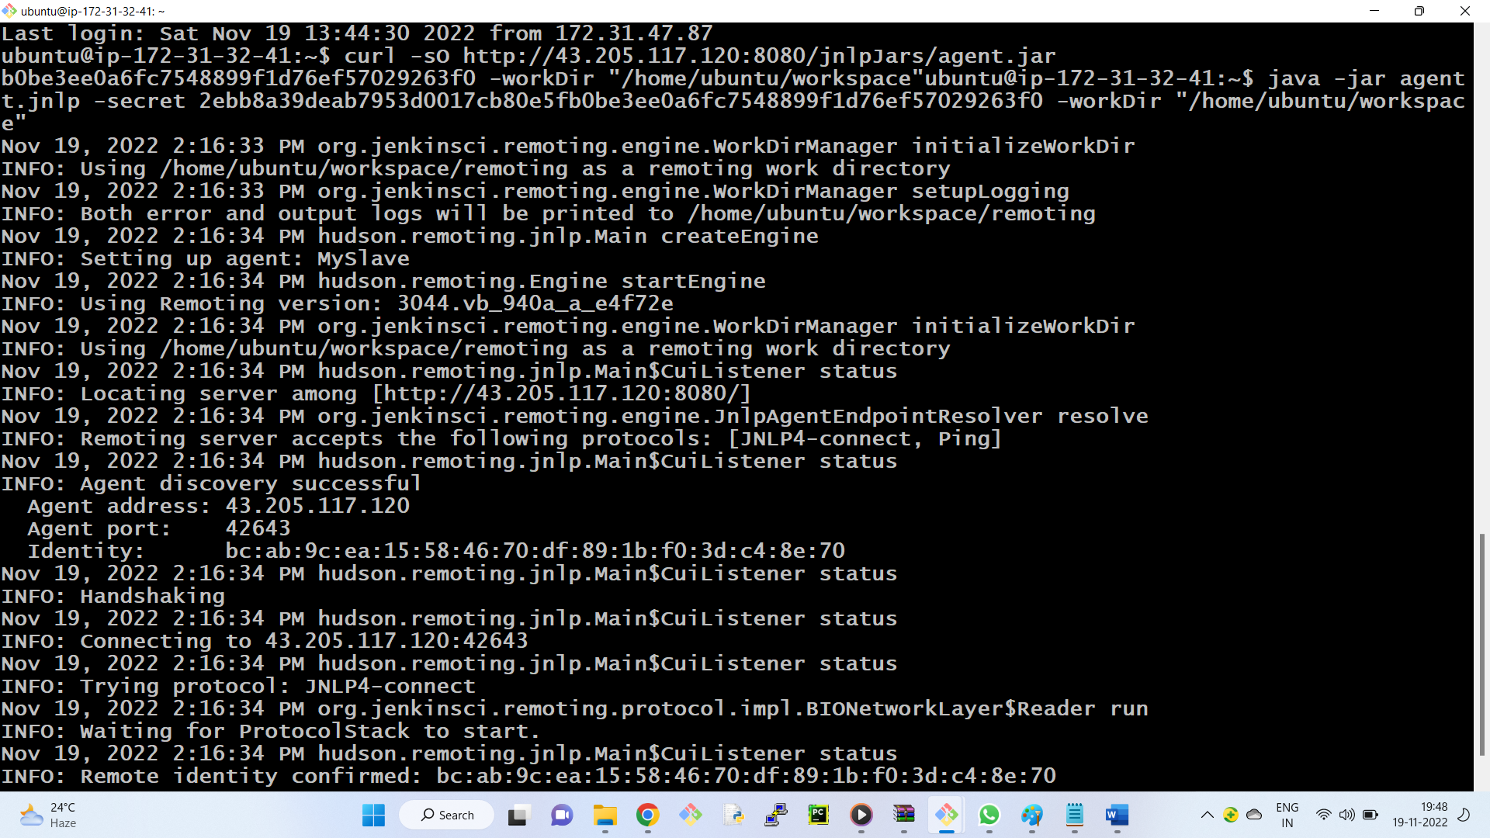

Now your machine will be ready.

